BUILD A SOHO NETWORK

Q1. Draw a network diagram for a small office/home office (SOHO) setup that includes: one broadband internet connection, one Wi-Fi router, two laptops, one smart TV, and one printer. Clearly label each device and connection type (wired or wireless).
Ans.
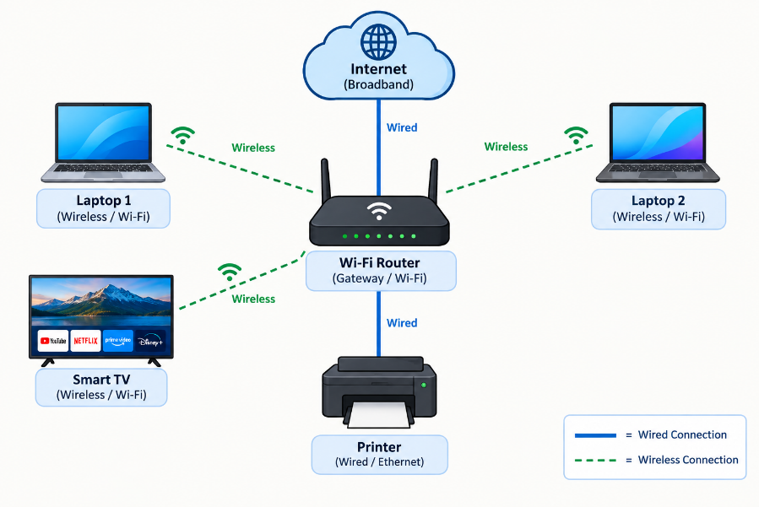
Q2. List all the hardware components (with brand/model suggestions) you would need to physically build the SOHO network diagrammed above, including cables and any switches or extenders if needed. Hint: Check current listings on Flipkart or Amazon for typical device models used in Indian homes/offices.
Ans. For the SOHO network in your diagram, you do not actually need a switch or extender for a normal-sized room/home. The router has enough LAN ports, and the laptops/TV can connect through Wi-Fi
NO. | Hardware | Suggested Models | Connections
1 | Broadband Internet Connection | Any local ISP — JioFiber, Airtel Xstream Fiber, GTPL, etc. | Wired to router
2 | Wi-Fi Router | TP-Link Archer AX23 AX1800 Wi-Fi 6 | Wired + Wireless
3 | Laptop 1 | Lenovo IdeaPad Slim 3 | Wireless
4 | Laptop 2 | HP 15s | Wireless
5 | Smart TV | Samsung 43-inch 4K Smart TV | Wireless
6 | Network Printer | HP Smart Tank 580 Wi-Fi | Wireless
7 | Ethernet Cables | Cat6 RJ45 cables | Wired
8 | Power Supply | Router/printer/TV adapters | Electrical
9 | Optional Switch | TP-Link TL-SG105 5-Port Gigabit | Wired
10 | Optional Wi-Fi Extender | TP-Link RE300 AC1200 | Wireless

Q3. Write step-by-step instructions to configure the Wi-Fi router for your SOHO network, including setting up a unique SSID, enabling WPA2 security, and changing the default admin password.
Ans. Steps to Configure the SOHO Wi-Fi Router
Step 1: Connect the router
- Connect the broadband/ONT Ethernet cable to the router's WAN/Internet port.
- Turn on the router.
- Connect a laptop to the router using Ethernet cable or the default Wi-Fi.
Step 2: Open the router settings
- Open Chrome or another web browser.
- Enter tplinkwifi.net in the address bar.
- If that does not work, try 192.168.0.1.
- Log in using the router's current admin credentials.
Step 3: Create a unique SSID
- Open Wireless/Wi-Fi Settings.
- Find Network Name (SSID).
- Change the default name to a unique name, for example:
  - SSID: SOHO_Home_Network
- Click Save/Apply.
Step 4: Enable WPA2 security
- Go to Wireless Security or Wi-Fi Security.
- Select WPA2-Personal / WPA2-PSK.
- Enter a strong Wi-Fi password, for example:
  - SOHO@2026Network!
- Click Save/Apply.
Step 5: Change the default admin password
- Go to Advanced → System → Administration (the wording may vary).
- Enter the current admin password.
- Create a new, strong administrator password.
- Click Save.
Important: The admin password and Wi-Fi password are different. The admin password protects the router's settings, while the Wi-Fi password allows devices to join the network.
Step 6: Reconnect the devices
- Select SOHO_Home_Network.
- Enter the new Wi-Fi password.
- Connect to the network.

Step 7: Test the network
- Open a website on both laptops.
- Connect the Smart TV to the new Wi-Fi.
- Print a test page from the printer.
- Confirm that all devices can access the Internet.
Q4. Configure IP addresses for all devices in your SOHO network: assign static IPs to the printer and smart TV, and use DHCP for the laptops. Show a table listing each device, its MAC address (make one up), and the assigned IP address.
Ans. IP Address Configuration for the SOHO Network
Assume the router uses 192.168.1.1/24 as the gateway. The printer and Smart TV use static IP addresses, while the laptops receive addresses automatically through DHCP.
Device | MAC Address (Example) | IP Address | Configuration
Wi-Fi Router | A4:5E:60:12:34:01 | 192.168.1.1 | Static / Gateway
Printer | A4:5E:60:12:34:02 | 192.168.1.10 | Static
Smart TV | A4:5E:60:12:34:03 | 192.168.1.20 | Static
Laptop 1 | A4:5E:60:12:34:04 | 192.168.1.100 | DHCP
Laptop 2 | A4:5E:60:12:34:05 | 192.168.1.101 | DHCP

Subnet mask: 255.255.255.0
Default gateway: 192.168.1.1
DHCP range: 192.168.1.100 – 192.168.1.200
Steps
- Log in to the Wi-Fi router.
- Set the router's LAN IP to 192.168.1.1.
- Enable DHCP and set its range to 192.168.1.100–192.168.1.200.
- Configure the printer with static IP 192.168.1.10.
- Configure the Smart TV with static IP 192.168.1.20.
- Set both laptops to Obtain an IP address automatically (DHCP).
- Check each device's IP address and verify that all devices can communicate with the router.
Q5. Explain how you would troubleshoot if one of the laptops cannot connect to the internet in your SOHO network. List at least 3 possible causes and what steps you would take to diagnose and fix each issue.
Ans. Troubleshooting a Laptop That Cannot Connect to the Internet
- If one laptop in the SOHO network cannot access the internet, I would check the following possible causes:
Possible Cause | Diagnosis Steps | Fix
1. Wi-Fi connection problem | Check whether Wi-Fi is turned on and the laptop is connected to the correct SSID. Check the Wi-Fi signal strength. | Turn Wi-Fi off and on, reconnect to the correct network, and move closer to the router if the signal is weak.
2. Incorrect IP address / DHCP problem | Open Command Prompt and run ipconfig. Check whether the laptop has an IP such as 192.168.1.100–192.168.1.200. | Run ipconfig /release followed by ipconfig /renew to obtain a new IP address from the router.
3. DNS or gateway problem | Use ipconfig to check the default gateway. Run ping 192.168.1.1 to test the router, then ping 8.8.8.8 to test internet connectivity. | Restart the router or correct the gateway/DNS settings. DNS can be set to 8.8.8.8 if required.
4. Router/internet connection problem | Check whether other devices connected to the same router can access the internet. | If all devices are offline, restart the router and check the ISP connection. Contact the ISP if the problem continues.

Example Diagnosis
- Check the laptop's Wi-Fi connection.
- Run ipconfig and verify its IP address.
- Ping the router: ping 192.168.1.1.
- Ping an internet address: ping 8.8.8.8.
- If the router responds but 8.8.8.8 does not, check the router/ISP connection.
- If 8.8.8.8 works but websites do not open, check DNS settings.
- Restart the laptop/router after making corrections and test the connection again.

